Title
(all nouns capitalised)
Subtitle, if any
(only the first word capitalised, except for names, etc.)

Dutch translation of the title
(only the first word capitalised, except for names, etc.)
Dutch translation of the subtitle, if any
(only the first word capitalised, except for names, etc.)

Thesis

to obtain the degree of Doctor from
Erasmus University Rotterdam
by command of the
rector magnificus

prof.dr.ir. A.J. Schuit

and in accordance with the decision of the Doctorate Board.
The public defence shall be held on

Day date (day month year) at 00:00 hrs
by

Name(s) Surname
born in City, Country.


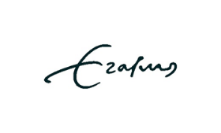
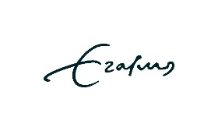


Doctoral Committee:

Promoter: | Use the same spelling as that of the rector magnificus on the front of the title page. No affiliations.
Co-promoter: | Use the same spelling as that of the rector magnificus on the front of the title page. No affiliations.
Assessment committee: | Use the same spelling as that of the rector magnificus on the front of the title page. No affilations.

